Lab1 documentation

his lab focuses on network measurements, setting up and testing the DeathStarBench suite, and running benchmarking tools like wrk2 on your setup
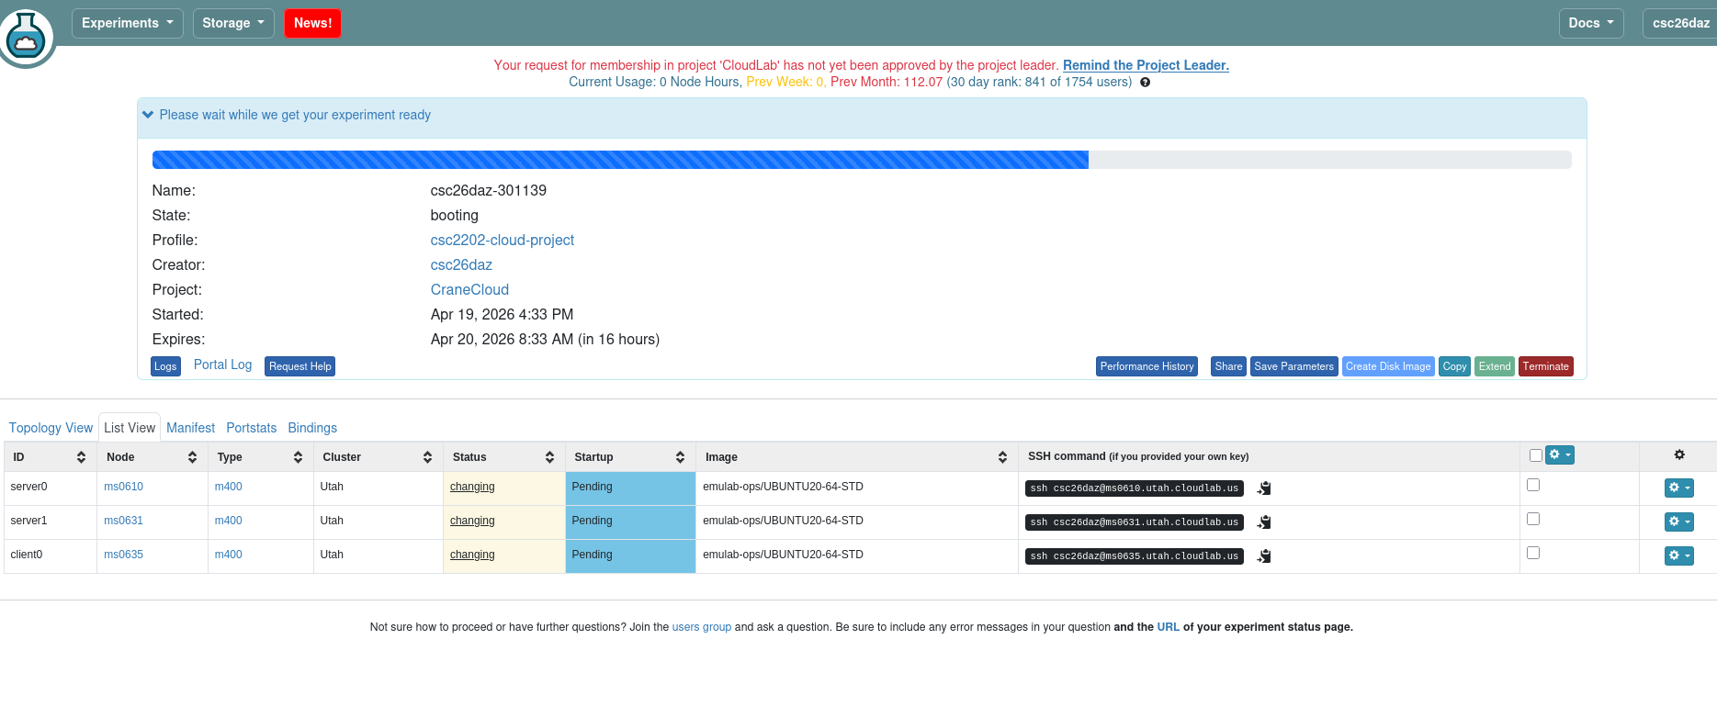
after few minutes it gets ready
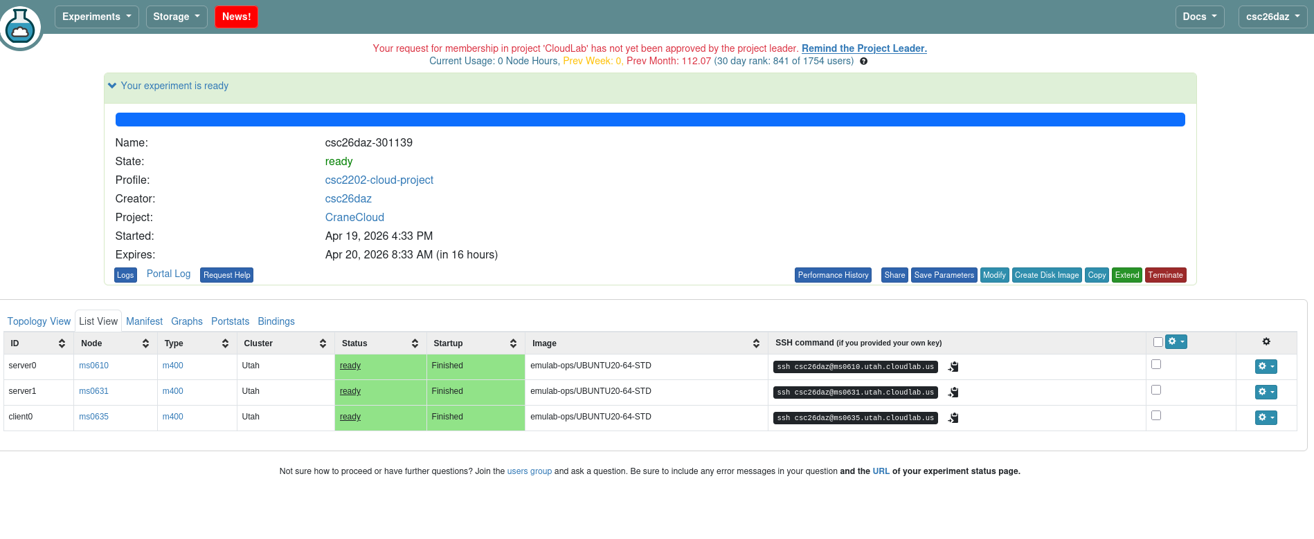
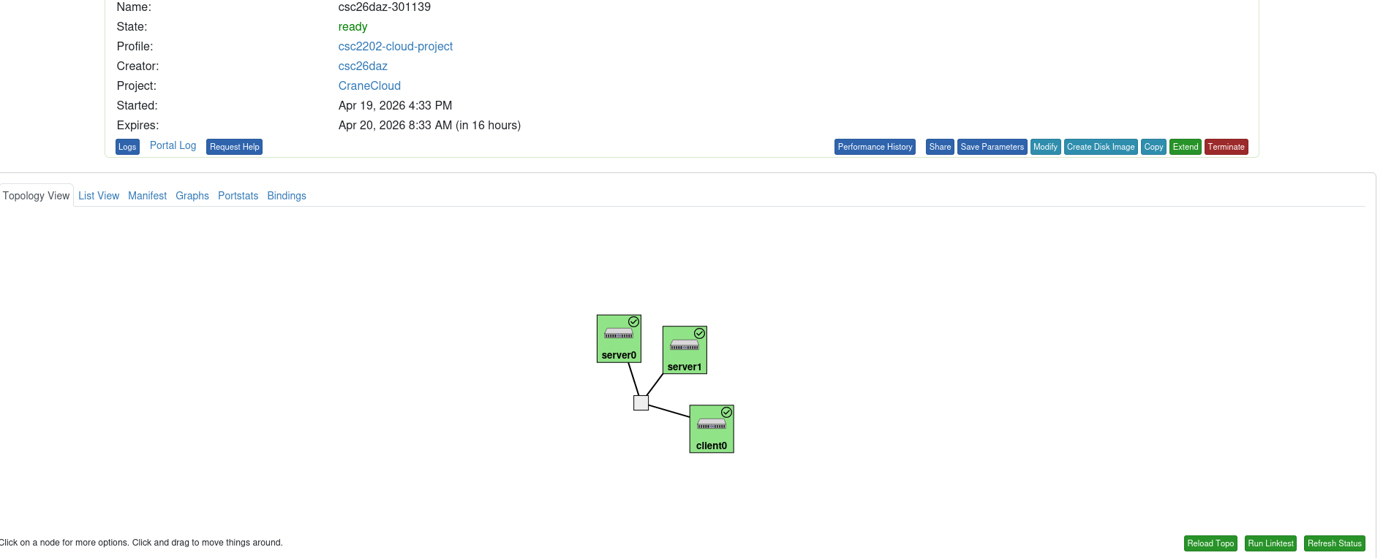
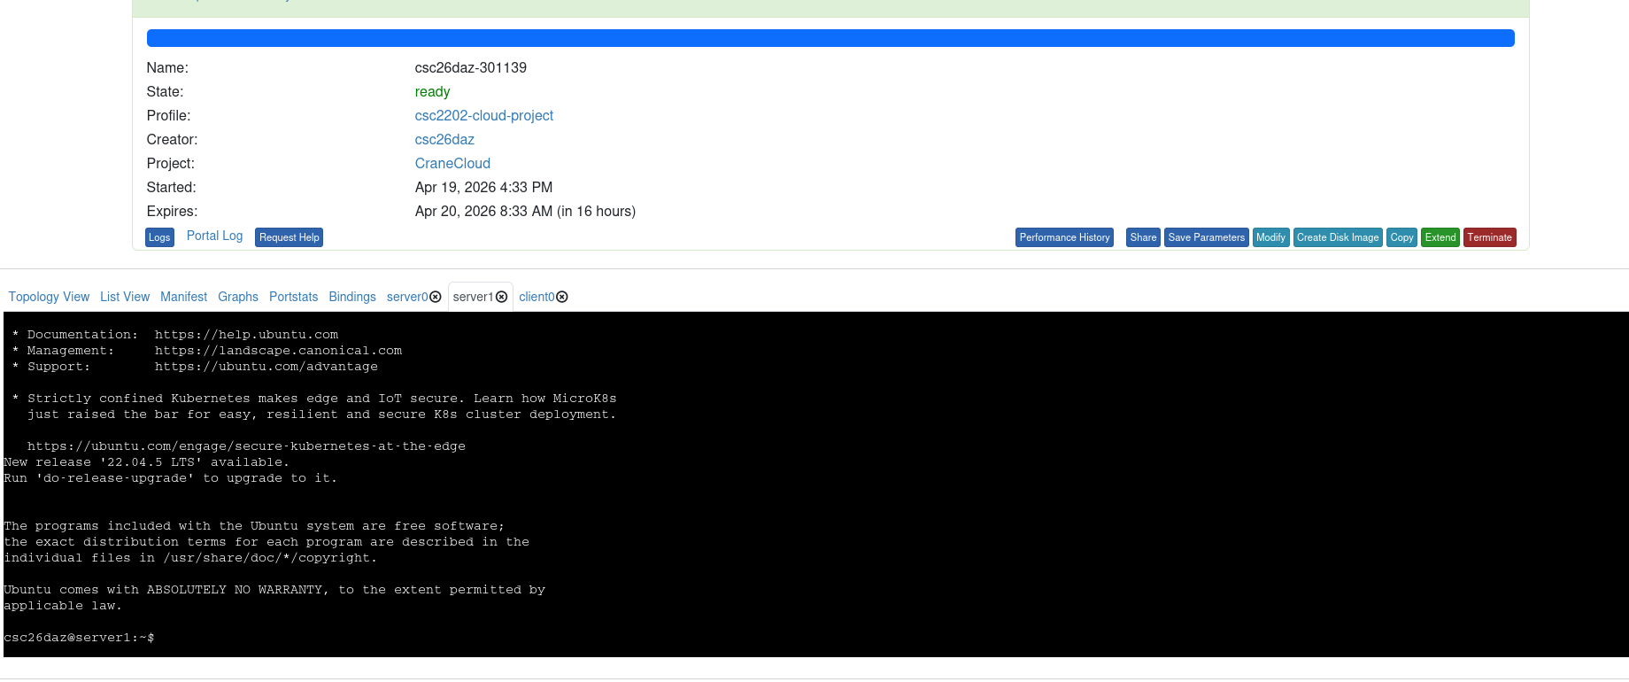
SSH into the first server (server0):
The -A flag allows you to forward your local SSH agent to the remote server, which is useful for accessing other servers or resources that need SSH authentication from the current sessio

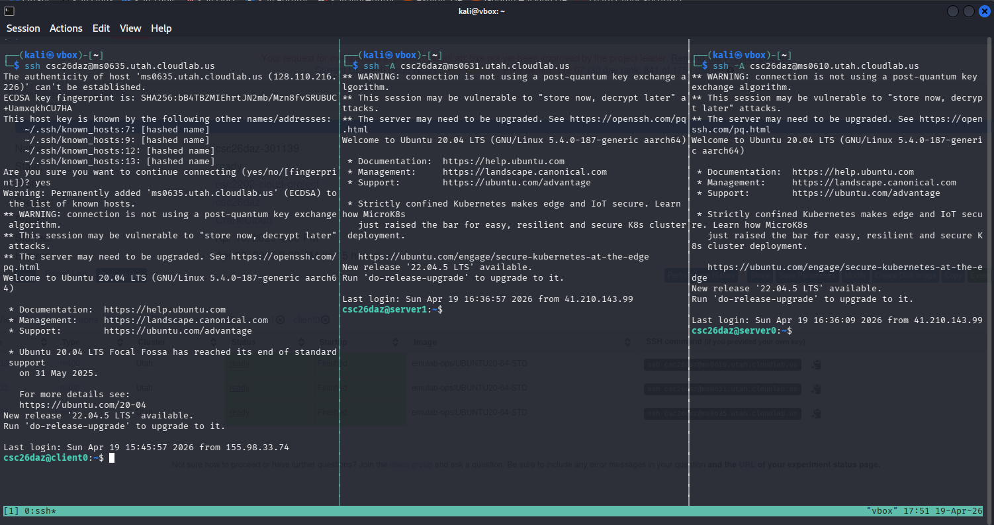

2. Run iperf3 to Measure Network Bandwidth
- On the server (server0), run the iperf3 server to listen for traffic:
- On the client (client0), run the iperf3 client to connect to the server and measure bandwidth:
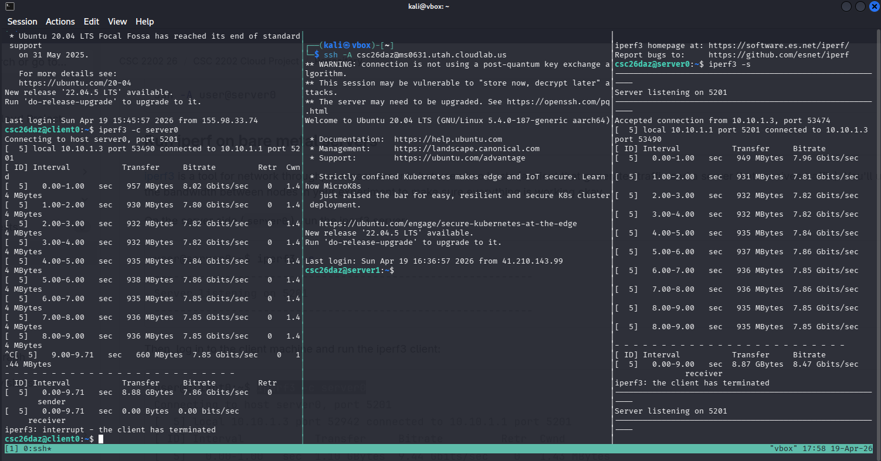
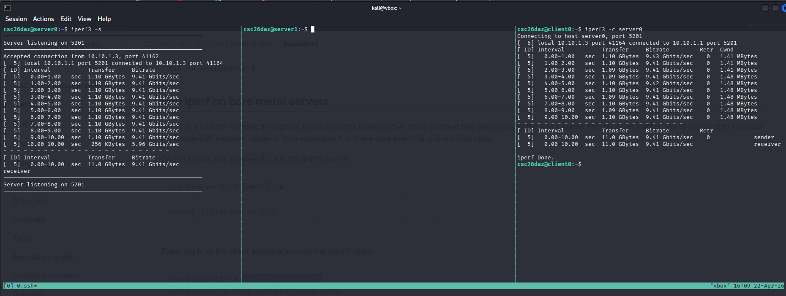

Prepare the Server for DeathStarBench
On server0, run the following commands to prepare it for deployment of DeathStarBench. This will install some utilities required by the bash scripts.
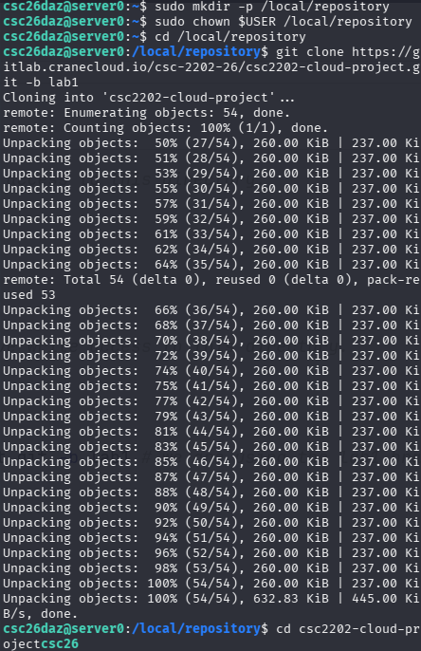

The SSH Key Problem
When you run ./start_docker.sh, the script tries to talk to other servers (server0, server1) to set up the "Swarm." It's failing because it doesn't have permission to log into them.
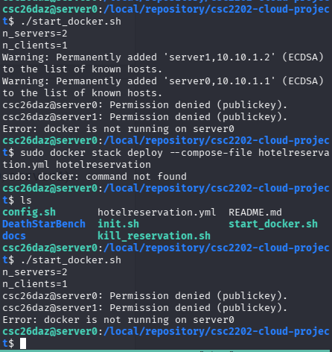
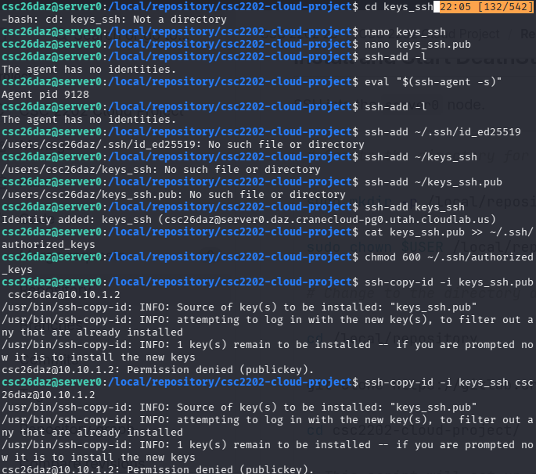

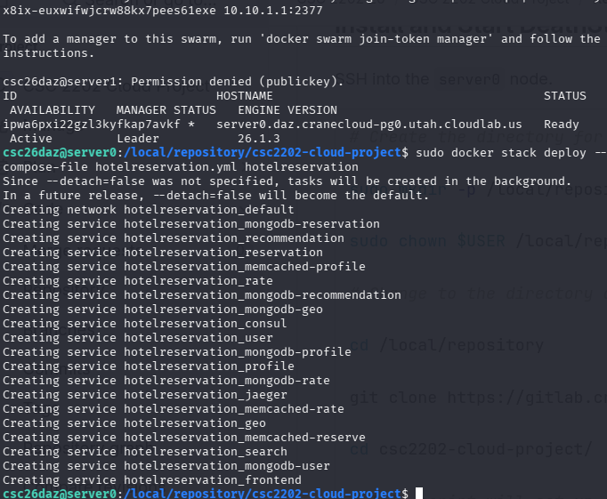

sudo docker service ls
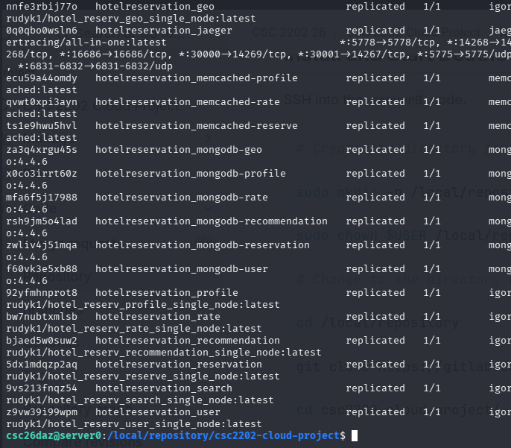

communication between server0 and server1 was setup through registering the ssh key manully to both servers. Copy the public key to authorised_key by nano

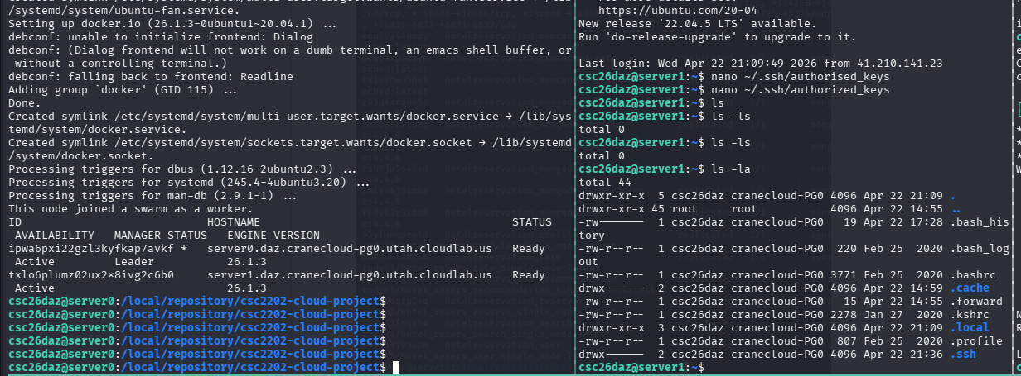
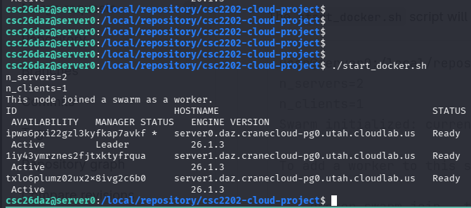

The docker stack deploy command will deploy the hotel reservation application, which is one of the applications in DeathStarBench, on the server machines. The output of this will be similar to the following:
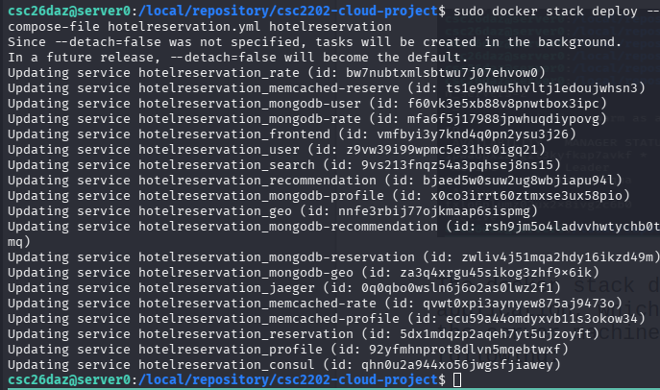
Testing DeathStarBench using curl

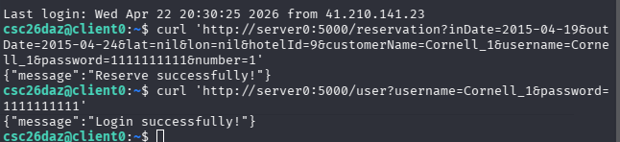
Running wrk2 on Client Machine
-update (sudo apt update)
-ufter u run “sudo apt install -y luarocks liblua5.1-dev luajit”
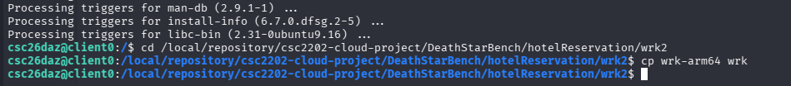
I can now run wrk2 to generate load to the hotel reservation application. For example, I can run the following command to send requests according to a schedule defined in the mixed-workload_type_1.lua script for 10 seconds with 10 threads and 100 connections. The -R option specifies the target request rate, which is 2000 requests per second in this case. The -L option enables latency recording

